**Gradient Descent for Univariate Linear Regression**

We have a hypothesis:

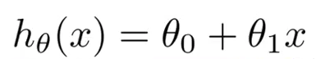

which we need fit to our training data. We can use a cost function such as Mean Squared Error:

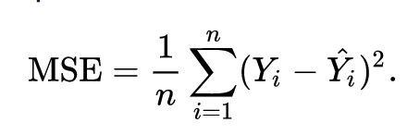

which we can minimize using gradient descent:

https://cdn-images-1.medium.com/max/800/1*QKHtyn4Rr-0R-s0an1eSsA.png

Which gives us linear regression!

